|  |  |  |
| --- | --- | --- |
|  | | |
| **CAPSTONE PROJECT 1** | | |
| **Project Title: “English For You”** | | |
| **ARCHITECTURE DESIGN DOCUMENT** | | |
|  | **Code**  **Version**  **Date** | **:** E4U  **:**  1.1  **:**  27 - Sep - 2018 |
| **TEAM: Fantastic 4**  **MENTOR:** Truong Tien Vu  **MEMBER:** Tran Nguyen Huu Nghia  Do Van Truong  Doan Nu Thuc Oanh  Dinh Tran Anh Truc  **International School – Duy Tan University** | | |

|  |  |  |  |  |  |  |  |  |  |  |  |  |  |  |  |  |  |  |  |  |  |  |  |  |  |  |  |  |  |  |  |  |  |  |  |  |  |  |  |  |  |  |  |  |  |  |  |  |  |  |  |  |  |  |  |  |  |
| --- | --- | --- | --- | --- | --- | --- | --- | --- | --- | --- | --- | --- | --- | --- | --- | --- | --- | --- | --- | --- | --- | --- | --- | --- | --- | --- | --- | --- | --- | --- | --- | --- | --- | --- | --- | --- | --- | --- | --- | --- | --- | --- | --- | --- | --- | --- | --- | --- | --- | --- | --- | --- | --- | --- | --- | --- | --- |
| **Project Information**   |  |  |  |  |  |  | | --- | --- | --- | --- | --- | --- | | **Project acronym** | Eng4you | | | | | | **Project Tittle** | [E4U] English For You | | | | | | **Start Date** | Aug 15, 2018 | | **End Date** | | Dec 5, 2018 | | **Lead Institution** | International School, Duy Tan University | | | | | | **Project Mentor & contact details** | Mr. Vu Truong Tien  Email: vudalat@yahoo.com  Tel: 0914083188 | | | | | | **Scrum Master & contact details** | Nghia ,Tran Nguyen Huu  Email: trannguyenhuunghia97@gmail.com  Tel: 0934848229 | | | | | | **Team members** | **Name** | **Email** | | **Tel** | | | Truong, Do Van | [Truongdtct1230@gmail.com](mailto:Truongdtct1230@gmail.com) | | 01674275453 | | | Oanh, Doan Nu Thuc | [Doannuthucoanh0410@gmail.com](mailto:Doannuthucoanh0410@gmail.com) | | 01674552075 | | | Truc, Dinh Tran Anh | [Anhtruc2091997@gmail.com](mailto:Anhtruc2091997@gmail.com) | | 0947360347 | | |

|  |  |  |  |
| --- | --- | --- | --- |
| **DOCUMENT NAME** | | | |
| **Document Title** | Architecture Design Document | | |
| **Author(s)** |  | | |
| **Role** | Team Member, Scrum Master | | |
| **Date** | 27 – Sep – 2018 | **File name:** | ArchitectureDesign |
| **URL** |  | | |
| **Access** |  | | |

|  |  |  |  |
| --- | --- | --- | --- |
| **REVISION HISTORY** | | | |
| **Version** | **Person** | **Date** | **Description** |
| 1.0 | Team | 22-Sep-2018 | Draft |
| 1.1 | Team | 24-Sep-2018 | Edit and update |

|  |  |  |  |
| --- | --- | --- | --- |
| **Document Approval**  The following signatures are required for approval of this document | | | |
| **Mentor** | Mr.Truong Tien Vu | **Signature:** |  |
| **Date:** |  |
| **Product owner** | Do Van Truong | **Signature:** |  |
| **Date:** |  |
| **Scrum master** | Nguyen Tran Huu Nghia | **Signature:** |  |
| **Date:** |  |
| **Team member(s)** | Do Van Truong | **Signature:** |  |
| **Date:** |  |
| Dinh Tran Anh Truc | **Signature:** |  |
| **Date:** |  |
| Doan Nu Thuc Oanh | **Signature:** |  |
| **Date:** |  |

**CONTENTS**

**1. Introduction 6**

1.1. Purpose 6

1.2. Documents Referenced 6

**2. Project Statement 6**

2.1. Project Overview 6

2.2. Business Driver 6

2.2.1. Business Problems 6

2.2.2. Business Need 6

2.3. Project Goals 7

**3. Architecture Drivers 8**

3.1. High-Level Requirements 8

3.2. System Context 8

3.3. Architecture Driver Specification 8

3.4. Quality Attributes 12

**4. Constraints 12**

4.1. Business Constraint 12

4.2. Technical Constraint 12

**5. High level architecture 13**

5.1. Component and Connector view (C&C view) 13

5.2. Module view 14

5.3. Allocation view 15

1. **Introduction**
   1. **Purpose**

This specification covers following:

* Brief specification of the project, high level requirement, system context for the system.
* Use case diagram, detail quality attribution.
* Architecture presented by various architecture view types: Component and Connect tor view, Module view, Allocation view.
  1. **Documents Referenced**

***Table 1: Document Reference***

|  |  |
| --- | --- |
| **No** | **References** |
| **1** | ProductBacklog |
| **2** | ProjectPlan |

1. **Project Statement**
   1. **Project Overview**

* Project name: **English For You**
* Development team:

***Table 2: Development team***

|  |  |
| --- | --- |
| **Full name** | **Position** |
| Nguyen Tran Huu Nghia | Scrum Master |
| Do Van Truong | Product Owner |
| Dinh Tran Anh Truc | Team Member |
| Doan Nu Thuc Oanh | Team Member |

* 1. **Business Driver**
     1. **Business Problems**
* English nowadays become second language
* Borings when learning English alone
* Lack of confidence in communication
* Need to much time to translate from native language to English
  + 1. **Business Need**
* Take initiative time to learning ( learning whenever they want)
* Communication with foreign to raise English skill
* Didn’t afraid when wrong
* An website can learning English and entertainment
* Interactive, co-operate with other people to learning English
  1. **Project Goals**

Two teams (two member in one team) take turns explaining and guessing by typing in English, how to score more than the opposing team while being timed. The explainer tries to help his teammates guess a word chosen from the randomly supplied list. Teams not in turn may also guess the word the facilitator is suggesting but will be rewarded with less points. Each player gets a turn to explain and guess. For each word is explained and guessed correctly, your team is awarded depending on the selected term of 50, 75 or 100 points.

***Describe:***

Step 1: Connect 4 players.

Step 2: Divided into two teams (A and B each have 2 players), default is A.

Step 3: Team A play, Team B attack.

Step 4: Team B play team A attack.

Step 5: Calculate points.

Step 6: End of a round.

***Define:***

***Play Team***: will be divided into explaners and answering players, and will be reversed at the end of a round.

- Explainer may change from or continue to explain when Answer are still not understand

- The Answer will receive the maximum score if the answer is correct.

***Attack Team***: can take the right answer while the team explains and will get half the score of the correct answer.

**Round 1**: Round 1 is when Team A plays and Team B attacks and switch.

**Finish the game**: Complete 2 rounds.

1. **Architecture Drivers**
   1. **High-Level Requirements**

Refer to E4U_ProductBacklog_Ver.1.0

* 1. **System Context**

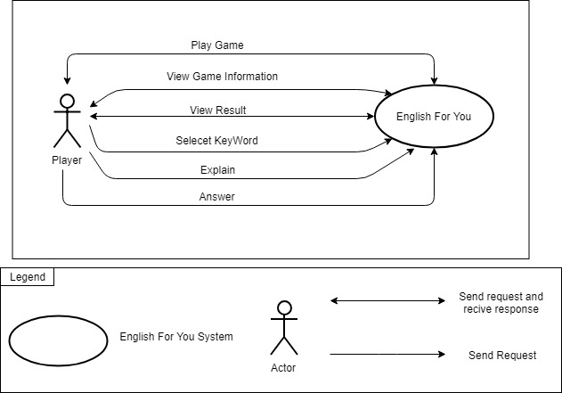

***Figure 1: System Context***

* Users: is the person who can manage information, play games and use functions in the system. They can get some notification from the system.

.

## Architecture Driver Specification

***Use Case Entities***

|  |  |
| --- | --- |
| ID | E01 |
| Title | Users |
| Description | Users who are using system and interact with website |
| Provides Assumptions | Provide person information, manage their posts |
| Requires Assumptions | Already have an account |
| Identified Use Cases | UC01: Login, UC02: Logout, UC03: Play Game, UC04: View Game Information, UC05: View Result, UC06: Select Key Word, UC07: Explain, UC08: Answer. |

***Operational Use Cases***

|  |  |
| --- | --- |
| ID | UC01 |
| Title | Login |
| Description | Click on Login to access into system by their account |
| Entities Involved | E01: User |
| Preconditions | Internet connection |
| Primary Flow | 1. User clicks on [Login with Facebook] button.  2. User visits on Home Page. |
| Post-conditions |  |
| Alternate Flows |  |

|  |  |
| --- | --- |
| ID | UC02 |
| Title | Logout |
| Description | Click on Logout to exit website |
| Entities Involved | E01: User |
| Preconditions | Successfully logged in the website |
| Primary Flow | 1. User clicks [Logout] button.  2. System checks and closes account. Return Home Page. |
| Post-conditions |  |
| Alternate Flows |  |

|  |  |
| --- | --- |
| ID | UC03 |
| Title | Play Game |
| Description | Click on Play button to start game |
| Entities Involved | E01: User |
| Preconditions | Successfully logged in the website |
| Primary Flow | 1. User clicks [Play] button.  2. Wait for system connect to other player.  3. If the connection is successful, the system will display the game interface. If the connection fails, return to step 2.  4. Play game. |
| Post-conditions |  |
| Alternate Flows |  |

|  |  |
| --- | --- |
| ID | UC04 |
| Title | View Game Information |
| Description | Click on Play button to start game |
| Entities Involved | E01: User |
| Preconditions | Successfully logged in the website |
| Primary Flow | 1. User clicks [Play] button.  2. Wait for system connect to other player.  3. If the connection is successful, the system will display the game interface. If the connection fails, return to step 2.  4. Play Game. Game information will be displayed on the game interface. |
| Post-conditions |  |
| Alternate Flows |  |

|  |  |
| --- | --- |
| ID | UC05 |
| Title | View Result |
| Description | Click on Play button to start game |
| Entities Involved | E01: User |
| Preconditions | Successfully logged in the website |
| Primary Flow | 1. User clicks [Play] button.  2. Wait for system connect to other player.  3. If the connection is successful, the system will display the game interface. If the connection fails, return to step 2.  4. Play Game.  5. When user are playing game, the scores will be display on the game interface. When user finish game, system will display the total scores on the message box. |
| Post-conditions |  |
| Alternate Flows |  |

|  |  |
| --- | --- |
| ID | UC06 |
| Title | Select Key Word |
| Description | Click on Play button to start game |
| Entities Involved | E01: User |
| Preconditions | Successfully logged in the website |
| Primary Flow | 1. User clicks [Play] button.  2. Wait for system connect to other player.  3. If the connection is successful, the system will display the game interface. If the connection fails, return to step 2.  4. Click [Play] and choose the key word you want. |
| Post-conditions |  |
| Alternate Flows |  |

|  |  |
| --- | --- |
| ID | UC07 |
| Title | Explain |
| Description | Click on Play button to start game |
| Entities Involved | E01: User |
| Preconditions | Successfully logged in the website |
| Primary Flow | 1. User clicks [Play] button.  2. Wait for system connect to other player.  3. If the connection is successful, the system will display the game interface. If the connection fails, return to step 2.  4. Choose the key word you want.  5. Enter words and sentences and click [Chat] button. |
| Post-conditions |  |
| Alternate Flows |  |

|  |  |
| --- | --- |
| ID | UC08 |
| Title | Answer |
| Description | Click on Play button to start game |
| Entities Involved | E01: User |
| Preconditions | Successfully logged in the website |
| Primary Flow | 1. User clicks [Play] button.  2. Wait for system connect to other player.  3. If the connection is successful, the system will display the game interface. If the connection fails, return to step 2.  4. Enter the word you think is right and click [Chat] button. |
| Post-conditions |  |
| Alternate Flows |  |

## Quality Attributes

***Table 3: Quality Attributes: Usability***

|  |  |
| --- | --- |
| **Quality Attributes** : Usability | **ID** : QA01 |
| **Stimulus** | Players will be instructed how to play before the game |
| **Source(s) of the stimulus** | User/System |
| **Relevant environmental conditions** | During using process. |
| **Architectural elements** | User guide, the system. |
| **System response** | Before entering the game the system will show you how to play the game and Friendly user interface is presented. |
| **Response measure(s)** | Users can use any functions of the system with just a few clicks and very easy to start using. |

***Table 4: Quality Attributes: Availability***

|  |  |
| --- | --- |
| **Quality Attributes** : Availability | **ID** : QA02 |
| **Stimulus** | The system is available 24 hours a day and players can play anywhere they have a network and a PC |
| **Source(s) of the stimulus** | User |
| **Relevant environmental conditions** | During using process. |
| **Architectural elements** | The system. |
| **System response** | fast access time, login time and fast gaming |
| **Response measure(s)** | The system operation automatically at 24/24 |

***Table 5: Quality Attributes: Maintainability***

|  |  |
| --- | --- |
| **Quality Attributes** : Maintainability | **ID** : QA03 |
| **Stimulus** | System Statistics will be easily when maintenance and upgrade |
| **Source(s) of the stimulus** | Admin |
| **Relevant environmental conditions** | During using process. |
| **Architectural elements** | The system |
| **System response** | when maintain system will be reported maintain time for player and maintain at night |
| **Response measure(s)** | Time maintain 1hour |

1. **Constraints**
   1. **Business Constraint**

* Project will be started on: 15 – Aug – 2018
* Project will be finished on: 05 – Dec – 2018
* Project will be finished in 119 days (812 hours).
  1. **Technical Constraint**
* Technical for Development

Technology: Nodejs , javascript , socket.io , mongoose

* Environment:

+ Operating system: Computer OS, any device used Web Browser.

+ Develop tools: Sublime text 3

+ Source version control: Git.

+ Database: Mongodb

+ Internet Connection.

1. **High level architecture**
   1. **Component and Connector view (C&C view)**

The diagram below shows the overview architecture including component and other related component. We have representations and behaviors for important components in the following sections.

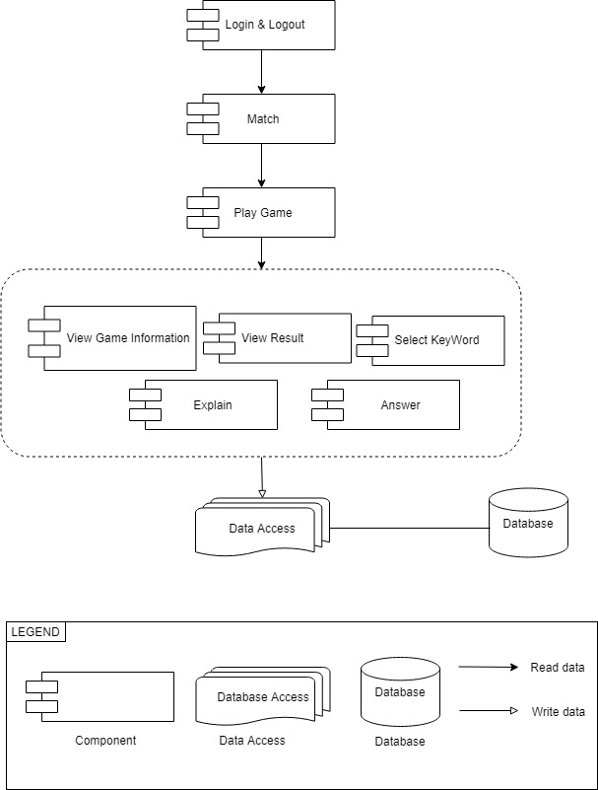

***Figure 2: C&C view***

**Prose:**

- User will use web browser and requires internet connection to access to system. One user accessed to system, the front-end interface will be displayed. With these front-end interfaces, user can go around the entire of the website. They can know which functions are on system easily. They will have a panoramic picture of some of the main functions of the system. From that, database from server can be transacted to users by back-end working.

- The website is authorized to access the database through data access.

1. **Module view**

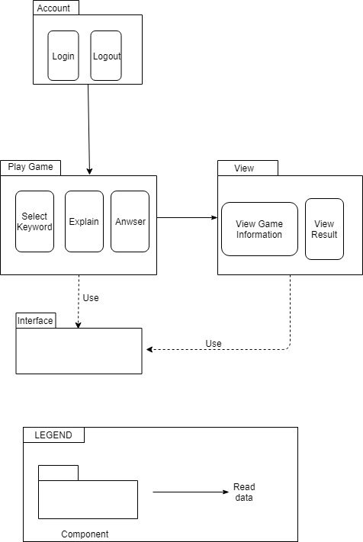

***Figure 3: Module view***

* **Prose:**

These modules have relationship and interact each other to create this system, module Login determines the functionality of users, after logging in successfully, it will be directed to the modules that users have permission to access. The functionality interacting each other, relationship will be defined by arrows.

* 1. **Allocation view**

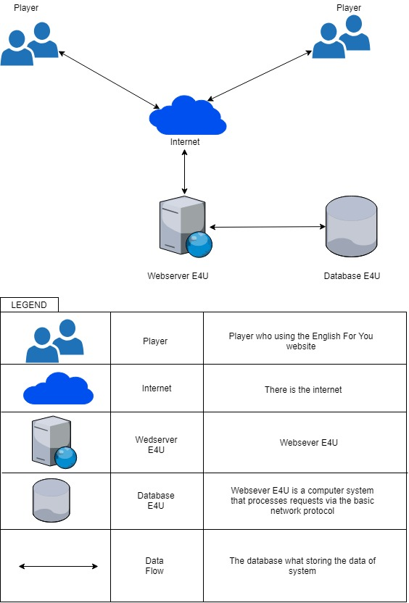

***Figure 4: Allocation view***

* **Prose:**

User will use web browser (Chrome, Firefox, Opera, Safari, ...) to can access to the system. It required have internet network if you use external link. Once you did access to the website, the webserver environment will be processed handle to interact database between user and system. Any transaction between user and system will be implemented on database.